Integration Specification

Grainger PLC
Salesforce - HomeLet Integration

Version 0.1
June 8, 2023
Contents

background

Overview
Grainger PLC has an existing Lead to Lease process implemented within their Salesforce org. As part of this process there is an existing point-to-point API integration between Salesforce and RightMove that facilitates the lease referencing process. Grainger PLC have taken the decision to move to the HomeLet lease referencing service instead of RightMove and need to make various changes to the relevant integrations.
The following Integration Specificaiton describes the process by which Grainger PLC’s Salesforce org will integrate to the HomeLet lease referencing service.

existing salesforce integrations
A 4-step, point-to-point integration has been implemented for Grainger PLC's current referencing solution as below:

- Ordering REST API callout from Salesforce to RightMove

- 1A: Order a new reference (from a Salesforce Opportunity by sending Opportunity and selected related Contact Roles)

- 1B: Cancel a reference order (from a Salesforce Opportunity) by sending a cancellation request from the Opportunity level

- 1C: Add applicants to an existing reference order (from a Salesforce Opportunity Contact Role level) if there is a currently active order

- 1D: Cancel one specific applicant on an existing reference order (from a Salesforce Opportunity Contact Role level) if there is a currently active order

- API callout from Leasing Portal to Salesforce using a Connected App to query Salesforce Opportunity Contact Roles to retrieve the RightMove frame URLs for every Contact Role

- Custom User Interface (Lightning Component) to handle authentication and expose RightMove Tracking Screen via an iFrame

- Webhook (API callout) from RightMove to Salesforce to update referencing status

New integrations

The future state using the HomeLet referencing service is shown in Figure 1 below. Integrations are annotated with 1A, 1B, 1C, 1D, 2 and 4 corresponding to integration numbering in 1.2 above. Integration 5 is a new integration not itemised in the list of current integrations above. 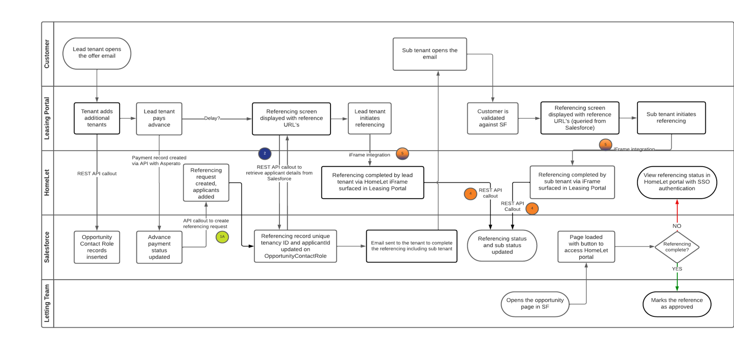
Figure 1 Initiating a new referencing request

The flow in Figure 1 above assumes that the Opportunity has already been created in Salesforce, an OpportunityContactRole record created and an offer email sent to the lead tenant. The process above starts with the lead tenant opening the offer email.

- Lead Tenant opens offer email and is taken to Grainger portal
- Lead tenant adds additional tenants (if any) within the Grainger portal
- Grainger portal creates additional OpportunityContactRole records in Salesforce (if any additional tenants were added)
- Lead tenant makes advance payment through Grainger portal
- Asperato integration updates Opportunity in Salesforce to reflect successful advance payment
- Salesforce calls out to HomeLet API (#1A in Figure 1) to initiate referencing.
- Grainger portal calls out to Salesforce to retrieve the tenancyId and ApplicantID (#2 in Figure 1)
- Grainger portal then proceeds to authenticate with Vision+ portal and display iFrame (#5 in Figure 1, the full details of the auth process are not shown in this diagram)
- HomeLet completes the referencing process and updates the status on the OpportunityContactRole records in Salesforce via the Salesforce API (#4 in in Figure 1)
- The referencing status is now recorded on the OpportunityContactRole records and the opportunity management process proceeds in Salesforce with no further interaction between HomeLet and Salesforce.

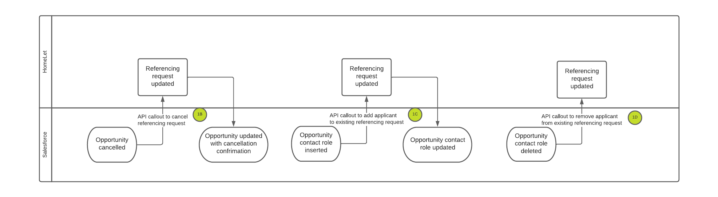
Figure 2 Cancelling a referencing request or adding new applicants

Changes will be required to be made as indicated below with colour coding to indicate responsibility for each item.

#1 Ordering REST API Callout from Salesforce to HomeLet | #2 API Callout from Leasing Portal to Salesforce via Connected App | #3 Expose referencing status in Salesforce | #4 API callout from HomeLet to Salesforce to update referencing status | #5 iFrame integration to expose HomeLet referencing process in Leasing Portal
Update endpoints and authentication callouts for 1A,1B,1C and 1D | Connected App setup (should already be done for current state) | Existing iFrame/Lightning Web Component removed from UI | Setup new Connected App for HomeLet | New integration to be developed on Leasing Portal
New record triggered flows to initiate invocable actions for 1A,1B,1C and 1D | Support for Connected App and API queries if required (minimal, if any, changes should be required to existing integration) | Update opportunity with URL with deeplinking to support SSO to HomeLet portal | Support for Connected App and API queries if required | Develop & support iFrame integration to HomeLet
Update invocable actions for HomeLet JSON structure and return values | Validate queries used to retrieve data from Salesforce (minimal, if any, changes should be required to existing integration) |  | Develop API callouts (including authentication) triggered within HomeLet to update Salesforce with referencing status
Update to existing logging framework to incorporate updated integrations
Apex test code to cover new/updated Apex code
Config setup to allow metadata driven switching between HomeLet and RightMove
Table 1Integration Changes & Responsibilities
Open Box Software | Grainger PLC Leasing Portal Development Team | HomeLet

References
- RightMove Integration Specification.pdf (2020-04-03)
- Vision+ API Documentation V r1.0.pdf
- Meeting with Scott Knight and Jaic George 2023-04-13
- Meeting with Scott Knight and Jaic George 2023-04-13

homelet integration details

Cutover strategy

When the HomeLet integration is first deployed to PROD, there will be a transition period when there are open opportunities with in progress referencing with RightMove. The new HomeLet integration has been designed so that these opportunities will complete the referencing process through RightMove, but any newly created opportunities will be referenced via HomeLet.

This is managed via a new “Referencing_Provider__c” field created on the Opportunity object.

Salesforce to homelet (1A, 1B, 1C, 1D)

Opportunity Object
The following fields are used in the integration

Object - Opportunity
Field Name | Type | Is Existing | Comments
Reference_Order_Cancel__c | Boolean | Yes | Existing field, used in HomeLet integration for
Reference_Order_Success_Datetime__c | DateTime | Yes | Reuse for same purpose
Reference_Order_Cancel_Datetime__c | DateTime | Yes | Reuse for same purpose
Referencing_Provider__c | PickList |  | New field.  Possible values – RrightMove, HomeLet (default)
Referencing_Property_Tenancy_Id__c | Number |  | New field

Object – Error Log
Field Name | Type | Is Existing | Comments
 |  |  | No new field introduced. Reuse object for same purpose

Object - OpportunityContactRole
Field Name | Type | Is Existing | Comments
Reference_Order_Success_Datetime__c | DateTime | Yes | Reuse for same purpose
Reference_Order_Cancel_Datetime__c | DateTime | Yes | Reuse for same purpose
Exempt_Referencing__c | Boolean | Yes | Reuse for same purpose
Referencing_Applicant_Id__c | Number |  | New field
Referencing_Applicant_Secret_Key__c | Text |  | New field

Custom Setting – Configuration__c
Field Name | Type | Is Existing | Comments
Referencing_Provider__c | Text |  | No new field. Stores default Referencing Provider for newly created opportunities. Possible values – RightMove, HomeLet

Authentication with Named Credentials

OpenBox has setup Named Credentials with configuration as follows for HomeLet Referencing API invocation. The permission set named - Referencing HL Callout should be assigned to users invoking the service.

Authentication settings are stored in a new Custom Metadata type named – Referencing_HL_Auth_Settings__mdt. This custom metadata type has following fields:

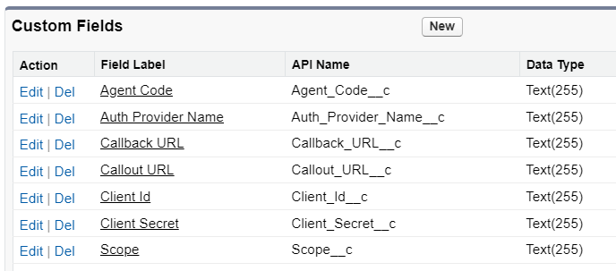
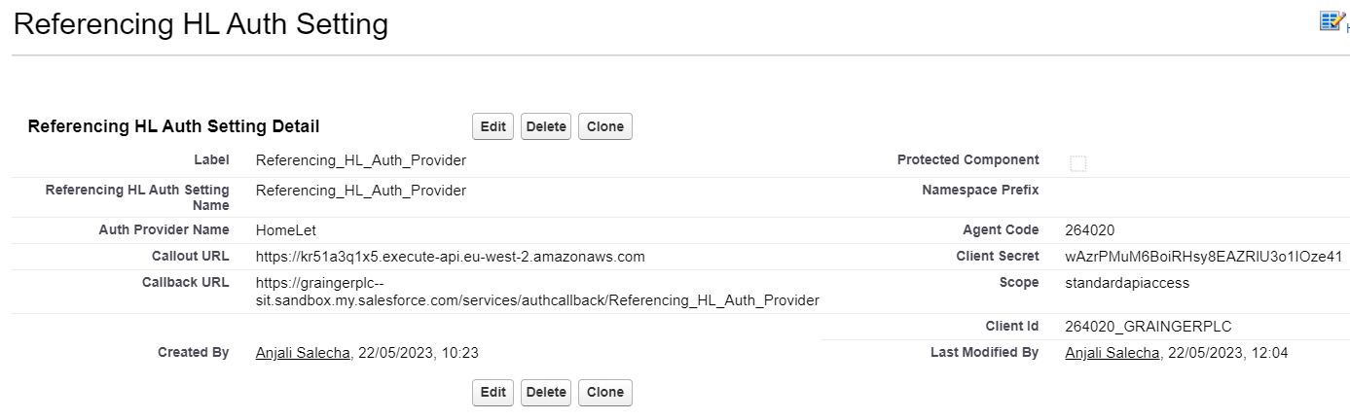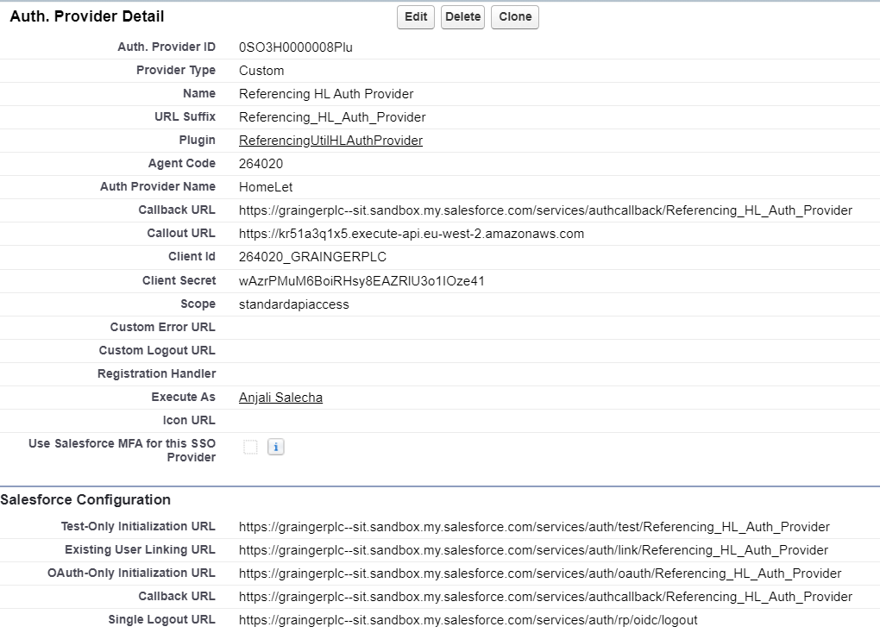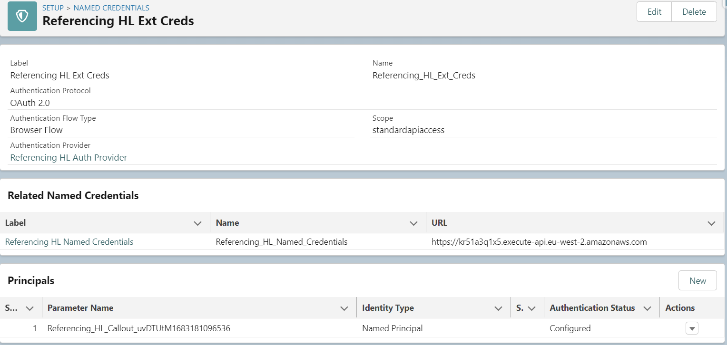

Default Integration Callout Values Configuration
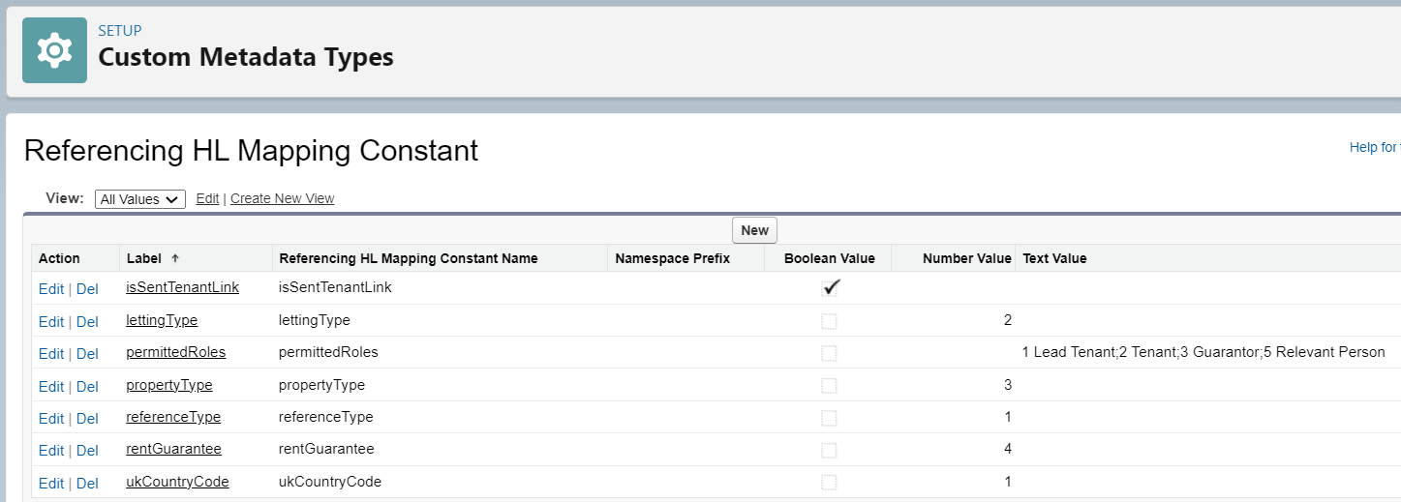

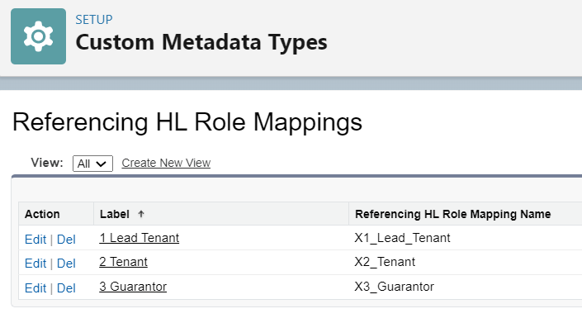
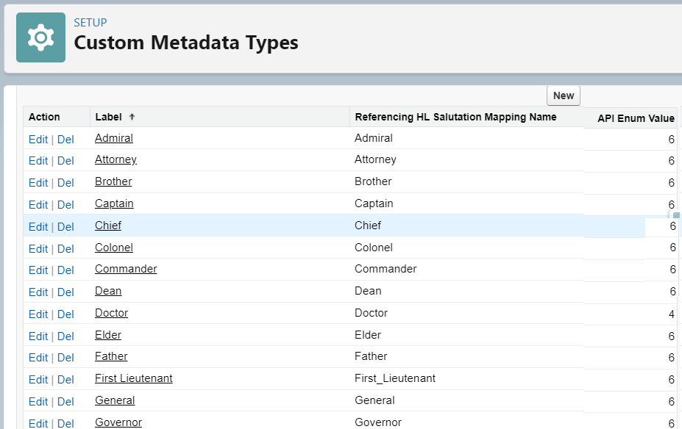

R

